ZOMATO EXPANSION PROJECT

Problem Statement.
You are hired as a consultant data analyst by Zomato where the team is looking for expansion and opening more restaurants. Your task is to develop strategies/suggestions for opening newer restaurants.

Contents
- Data Pre-Processing and Data Cleaning.
- Objective Questions.
- Subjective Questions.

Data Pre-Processing and Data Cleaning.
- Removed duplicates from whole table of raw data provided.
- Handled missing values in data.
- Data Types of Column is properly checked.
- Removed unwanted columns.
- A new column is added with name ‘Customised Price’ for each restaurant with currency symbols.
- Year is extracted in ‘Year’ column from ‘Datekey_Opening’ column for yearly analysis.
- Converted ‘Average Cost for Two’ in to Indian National Rupee (INR) in new column ‘Average Cost for Two in INR’ for proper analysis.

OBJECTIVE QUESTIONS

Question 1: What is the total no. of tables present in the data?

Solution:

Final Answer :
2

Charts & Tables :
- Raw Data
- Country Description

Question 2: What is the total no. of attributes present in the data?

Solution:

Final Answer :
There are 22 attributes present in the data provided

Approach :
Including the Country Name (Objective Question 5) and Average_cost_for_two with currency symbol (Objective Question 12)

Question 3: How many categorical columns are there in the data?

Solution:

Final Answer :
There are 10 categorical columns in the raw data found using COUNTIF function ‘=COUNTA(UNIQUE(range))’ on each column individually.
Serial no. | Column Name
1 | City
2 | Restaurant Name
3 | Country
4 | Cuisines
5 | Has online delivery
6 | Switch to order menu
7 | Is delivering now
8 | locality
9 | currency
10 | Has table booking

Question 4: The data consists of some inconsistent and missing values so ensure that the data used for further analysis is cleaned.

Solution:

Final Answer :
The data cleaning has been done to columns like cuisines were there were missing values or blank values

Approach :
Methods used for data inconsistency and missing values are :-
- To Find out missing data I have used ‘Filter Function’.
- Applied Filter on Each Columns and searched for ‘Blank’
- I found missing values in Column ‘Cuisines’
- To make data more consistent I extracted “year” from date of opening provided for proper analysis. Formulae used to extract year mentioned below: =YEAR(T2)

Question 5: Using the LookUp functions, fill up the countries in the original data using the country code.

Solution:

Final Answer :
VLOOKUP

Approach :
=VLOOKUP(C3,'country description'!$A$1:$B$16,2,0)

Charts & Tables :
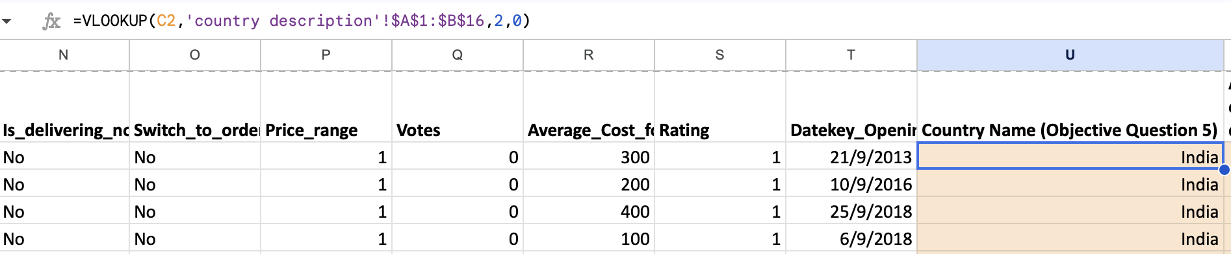

Question 6: Create a table to represent the number of restaurants opened in each country.

Solution:

Final Answer :
9551

Approach :
Created a Pivot table to show the number of restaurants in each country

Charts & Tables :

Country Name (Objective Question 5) | COUNTA of RestaurantID
Australia | 24
Brazil | 60
Canada | 4
India | 8652
Indonesia | 21
New Zealand | 40
Philippines | 22
Qatar | 20
Singapore | 20
South Africa | 60
Sri Lanka | 20
Turkey | 34
United Arab Emirates | 60
United Kingdom | 80
United States of America | 434
Grand Total | 9551

Pivot Table
- Description:
It represents the number of restaurants opened in each country along with the Grand Total from the data, where we have used Country under the rows attribute and COUNTA of Restaurant IDs

Question 7: Also, the management wants to look at the number of restaurants opened each year, so provide them with something here.

Solution:

Final Answer :
Year of Opening | COUNTA of RestaurantID
2010 | 1080
2011 | 1098
2012 | 1022
2013 | 1061
2014 | 1051
2015 | 1024
2016 | 1027
2017 | 1086
2018 | 1102
Grand Total | 9551

Approach):
Used restaurant IDs as a value and Year as a row attribute

Charts & Tables :
Line Chart
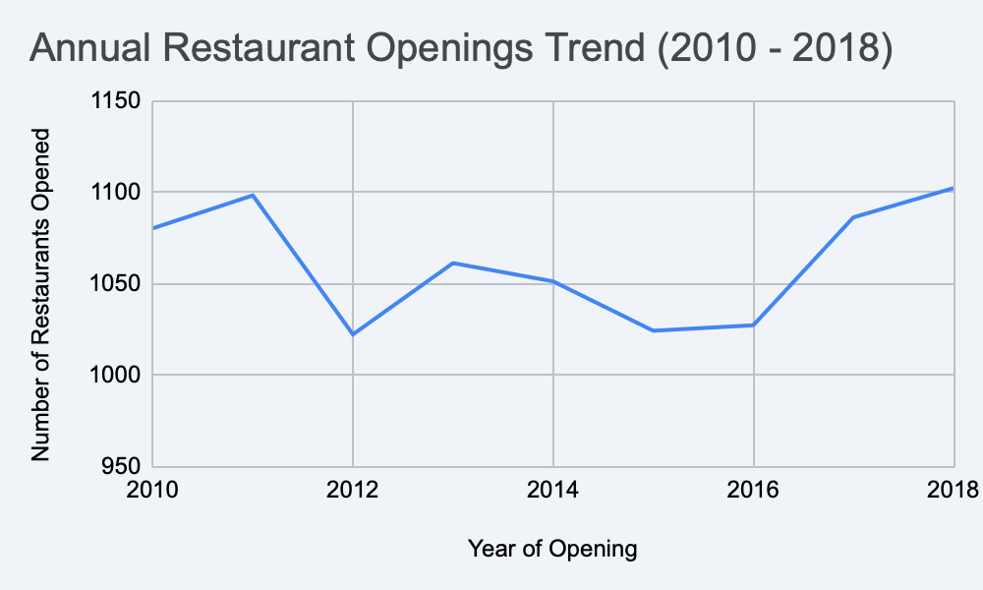

Question 8: What is the total number of restaurants in India in the price range of 4?

Solution:

Final Answer :
Total number of restaurants in India in the price range 4 is found out to be using the below given formula 388

Approach :
COUNTIFS('Cleaned Data'!$U:$U,"India",'Cleaned Data'!$P:$P,"4")

Question 9: What is the average number of voters for the restaurants in each country according to the data?

Solution:

Final Answer :

Country Name | AVERAGE of Votes
Australia | 111.42
Brazil | 19.62
Canada | 103.00
India | 137.21
Indonesia | 772.10
New Zealand | 243.03
Philippines | 407.41
Qatar | 163.80
Singapore | 31.90
South Africa | 315.17
Sri Lanka | 146.45
Turkey | 431.47
United Arab Emirates | 493.52
United Kingdom | 205.49
United States of America | 428.22

Approach :
Used a Pivot Table with Country in Rows and Average Votes in Values

Charts & Tables :
Bar Chart
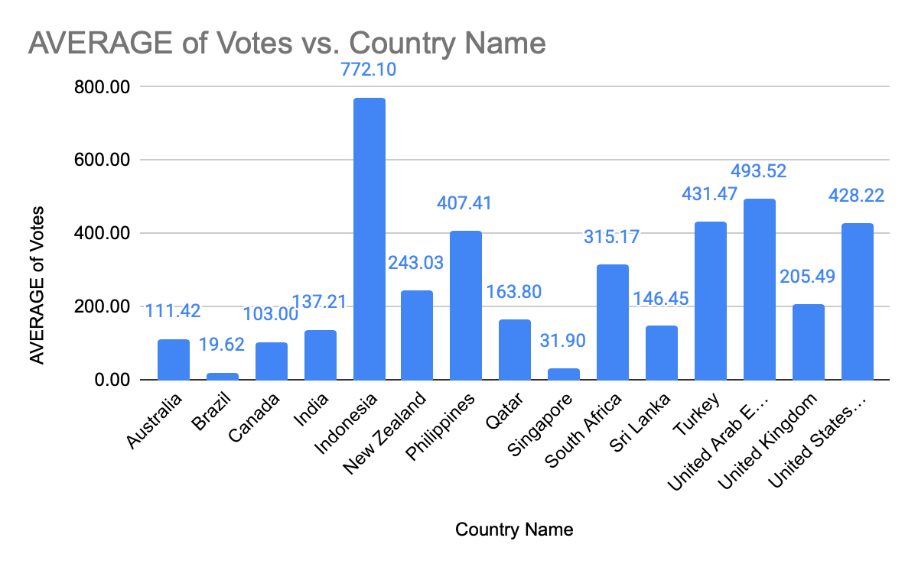

Question 10: Calculate the average rating for all the restaurants that have price_range < 4 and provide online delivery. Use only the “IF” function, Logical Operators, and Aggregation functions to solve this problem. [Note: Don’t use Conditional aggregation in this question.]

Solution:

Final Answer :
3.27381

Approach :
used IF function with logical operators to fulfil the criteria based evaluation needed in question. AVERAGE function is used to calculate average ratings for the both criteria given above and formulae used are mentioned below:
=AVERAGEIFS('Cleaned Data'!S:S,'Cleaned Data'!M:M,"Yes",'Cleaned Data'!P:P,"<4")

Question 11: Using Conditional formatting highlight the rows of restaurants that are located in the countries or cities that you’ve suggested to the management for opening new restaurants.

Solution:

Final Answer :
Kolkata,New Delhi,Noida,Mumbai,Hyderabad,Kochi,Nagpur,Pune etc

Approach :

=IF(AND($S717>3,$M717="Yes",$P717<4),"Suggested","Not Suggested")

The rating should be greater than 3, there should be online delivery available and price range should be less than 4

Question 12: Create a new customized price column that consists of the abbreviation/symbol of the currency along with the Average_cost_for_two value. [Use string operations to do this task]

Solution:

Final Answer :
Rs. 300
$ 50

Approach :
= MID($K2, FIND("(", $K2) + 1, FIND(")", $K2) - FIND("(", $K2) - 1) & " " & $R2

Charts & Tables :

Average_cost_for_two with currency symbol (Objective question 12)
Rs. 300
Rs. 200
Rs. 400
Rs. 100

Question 13: How can you create an array formula in Excel or Google Sheets to count the number of restaurants listed that do not offer online delivery, are in the lowest price range, and have an average cost for two people less than or equal to 250 Indian Rupees?

Solution:

Final Answer :
1685

Approach :
Considering these 3 conditions
- ‘No’ online delivery
- ‘Lowest’ price range (price range = 1)
- Average cost for two ‘≤ 250 INR
=ARRAYFORMULA(SUM(('Cleaned Data'!M2:M9552="No") * ('Cleaned Data'!P2:P9552=1) * ('Cleaned Data'!R2:R9552<=250) * ('Cleaned Data'!K2:K9552="Indian Rupees(Rs.)")))

SUBJECTIVE QUESTIONS

Question 1: Suggest a few countries where the team can open newer restaurants with lesser competition. Which visualization/technique will you use here to justify the suggestions?

Solution:

Approach:
Conditions considered to suggest these countries
- Pivot table analysis targets countries with <30 restaurant IDs and <3.5 average ratings.
- Rows represent countries, with values showing average rating and the count of restaurants
Charts & Tables:
Pivot Table

Country Name | COUNTA of RestaurantID
Canada | 4
Qatar | 20
Singapore | 20
Sri Lanka | 20
Indonesia | 21

- Description:
The table represents number of restaurants in each country a

Insights:
- Low average ratings and restaurant count indicate a quality-based gap
- Entering a market with low restaurant count provides a first-mover advantage, enabling brand recognition and prime location acquisition
- Adapting to local tastes and socioeconomic realities is crucial for success, as existing restaurants may be failing to meet customer expectations
Recommendations:
Canada,Qatar,Singapore,Sri Lanka, Indonesia

Average rating

Country Name | AVERAGE of Rating
Australia | 3.66
Brazil | 3.85
Canada | 3.58
Singapore | 3.58
Sri Lanka | 3.87

Question 2: Come up with the names of States and cities in the suggested countries suitable for opening restaurants.

Solution:

Approach:
- Online Delivery Availability: The restaurant must support online delivery
- Customer Rating Tier: The restaurant must have an established customer rating of 3.1 or higher
- Affordability / Price Tier: The restaurant's price range must be 3 or less

Charts & Tables:

Country | State / Province | City | Existing Restaurants | Average Rating
Brazil | Distrito Federal | Brasília | 20 | 3.55
Brazil | Rio de Janeiro | Rio de Janeiro | 20 | 4.32
Brazil | São Paulo | São Paulo | 20 | 3.68
Canada | Ontario | Chatham-Kent | 1 | 3.7
Canada | Alberta | Consort | 1 | 3
Indonesia | West Java | Bandung | 1 | 4.2
Indonesia | Banten | Tangerang | 2 | 4.3
Singapore | Singapore (City-State) | Singapore | 20 | 3.58
Sri Lanka | Western Province | Colombo | 20 | 3.87

Insights:
- Indonesian cities like Tangerang and Bandung show exceptional average ratings (4.30 and 4.20) despite having very few existing restaurants

- Rio de Janeiro (Brazil) stands out as a highly successful market, maintaining a top-tier average rating of 4.32 across a solid base of 20 existing restaurants

- Cities like Singapore, Brasília, and São Paulo are highly competitive with 20 existing restaurants each, but they suffer from lower average ratings indicating potential customer dissatisfaction or gaps in quality

Recommendations:
- Aggressively target Tangerang and Bandung to capture early market share where consumer sentiment is highly positive and competition is minimal

- Enter Rio de Janeiro with a premium or highly differentiated culinary concept to align with the city's established high-quality dining standards

- In highly competitive markets like Singapore and São Paulo, focus on displacing existing mediocre options by offering superior food quality, service, or unique themes

- Put expansion plans on hold for low-performing, low-density locations like Consort (Canada) unless a thorough local market gap analysis reveals a specific unfulfilled need

Question 3: According to the countries you suggested, what is the current quality regarding ratings for restaurants that are open there?

Solution:
Approach:
Used a Pivot Table to find out ratings in the suggested places

Charts & Tables:
Table / Chart Name:
Pivot Table

Country Name (Objective Question 5) | AVERAGE of Rating
Canada | 3.58
Singapore | 3.58
Sri Lanka | 3.87
Qatar | 4.06
Indonesia | 4.30

- Description:
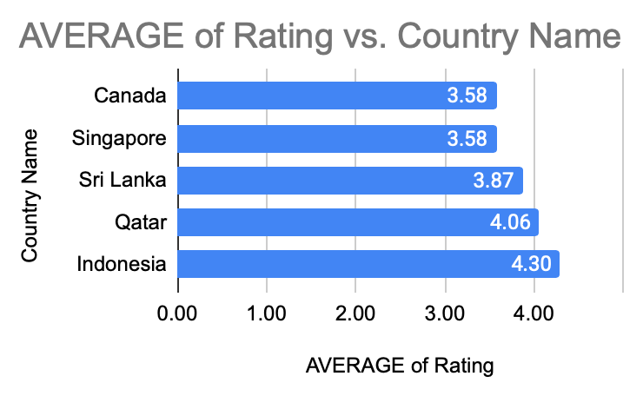
A comparison of the average aggregate ratings across Canada, Indonesia, Qatar, Singapore, and Sri Lanka to identify the quality regarding ratings

Insights:
Indonesia (4.30) and Qatar (4.06) have the highest quality standards

Recommendations:
For Indonesia & Qatar: The team should launch with a "Premium" or "Luxury" service model

Question 4: Also, what is the current expenditure on food in the suggested countries, so we can keep our financial expenditure in control?

Solution:

Approach:
Analyzing the Average_Cost_for_two attribute across the five suggested countries
The given average cost for 2 is given according to the countries currency

Charts & Tables:
- Table / Chart Name:
Pivot Table

Expenditure Calculated | Average price for two in RUPEES
Canada | 12870.2
Singapore | 276487.4
Qatar | 109100.5
Sri Lanka | 13775
Indonesia | 31887

Description:
Comparing the mean cost for two people across the selected regions, in their respective currencies

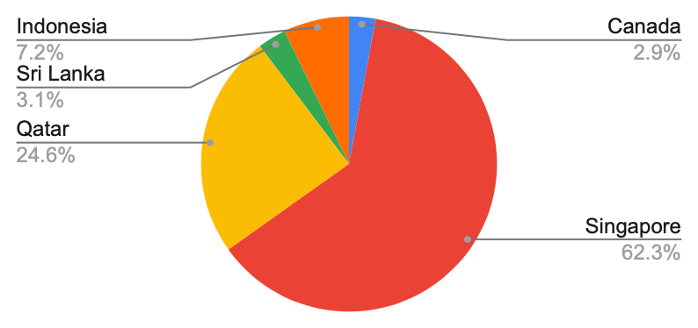

Insights:

Indonesia and Sri Lanka have high nominal values due to currency , while Qatar and Singapore represent higher-value markets in terms of actual purchasing power.

This shows Singapore food spending with ₹2.6 lakh , accounting for the vast majority of total expenditure due to its high average dining costs, larger number of restaurant suggestions

Recommendations:
- Higher financial budget for countries like Qutar and Singapore for their higher purchasing power

- We can be planning to implement average meal price and number of reviewed restaurants. Allocate most of the food budget there but impose a strict spending cap

- Boost review numbers in Sri Lanka, Brazil, and Canada to maximise content and keep costs down

Question 5: Come up with the names of restaurants from the recommended states that are our biggest competitors and also those that are rated in the lower brackets, i.e. 1-2 or 2-3.

Solution:

Approach:
Pivot Table and applied a Filter to focus only on the five suggested countries by sorting the data by Rating
Charts & Tables:
Pivot Table

RestaurantName | Country Name (Objective Question 5) | MAX of Rating
Talaga Sampireun | Indonesia | 4.9
Sushi Masa | Indonesia | 4.9
Ministry of Crab | Sri Lanka | 4.9
Mainland China Restaurant | Qatar | 4.9
Gymkhana | Qatar | 4.7
Zaffran Dining Experience | Qatar | 4.6

Potato Head Folk | Singapore | 3.1
Makansutra Gluttons Bay | Singapore | 3
Consort Restaurant | Canada | 3
Queen's Cafe | Sri Lanka | 2.5
Elite Indian Restaurant | Sri Lanka | 2.4

Description:
This table identifies the specific restaurants that dominate the market in our target regions and those that are failing to meet customer expectations.

Insights:

Biggest Competitors (Top Performers):

Talaga Sampireun (Jakarta & Tangerang, Indonesia) – Rating: 4.9

Ministry of Crab (Colombo, Sri Lanka) – Rating: 4.9

Mainland China Restaurant (Doha, Qatar) – Rating: 4.9

Sushi Masa (Jakarta, Indonesia) – Rating: 4.9

Lower Bracket (Ratings 1-3):

Elite Indian Restaurant (Colombo, Sri Lanka) – Rating: 2.4

Queen's Cafe (Colombo, Sri Lanka) – Rating: 2.5

Consort Restaurant (Consort, Canada) – Rating: 3.0

Makansutra Gluttons Bay (Singapore) – Rating: 3.0

Recommendations:
For Lower Rated Restaurants

We can conduct partner reviews, remove consistently poor performers, and onboard more reliable replacements

We can see to that restaurants follow staff training, menu updates, and act on
comprehensive service reviews

Question 6: Which cuisines should we focus on in the newer restaurants to get better feedback? Does the choice of cuisines affect the restaurant ratings?

Solution:

Approach:
Few of the restaurants were offering multiple cuisines so the Cuisines column was first normalized by splitting multiple cuisines into separate rows, ensuring that each cuisine was analyzed individually
A Pivot Table was created to calculate the number of restaurants offering each cuisine and the average customer rating for that cuisine

Criteria followed to recommend top 10 cuisines were that each cuisine must be having more than 200 restaurants and an average rating above 3.0

Charts & Tables:
The whole data acquired is in the sheet under the name Subjective Question 6

Row Labels | Count of RestaurantID | Average of Rating
Asian | 233 | 3.84
American | 390 | 3.69
Thai | 234 | 3.68
Italian | 764 | 3.61
Continental | 736 | 3.57
Burger | 251 | 3.57
Cafe | 703 | 3.42
Desserts | 653 | 3.15
Pizza | 381 | 3.06

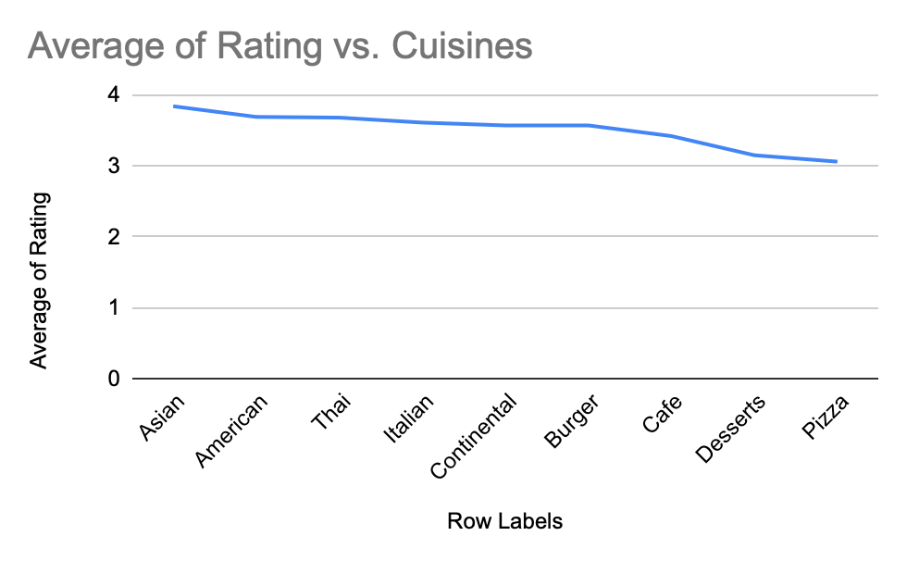
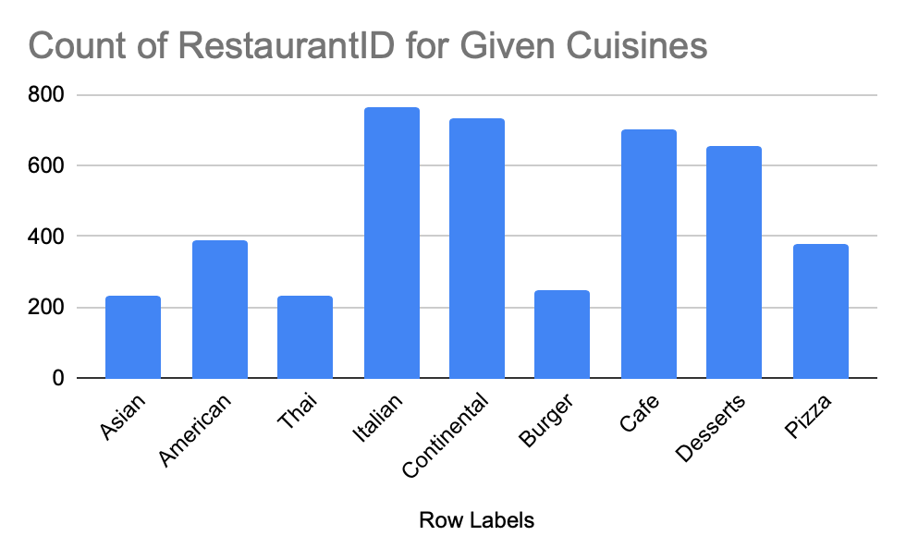

Description:
The above data and charts shows the top cuisines recommended to pick for the expansion

Insights:
- Popular cuisines such as North Indian and Chinese have the highest restaurant counts but relatively lower average ratings (below 3.0)
- Cuisines such as American, Italian, Continental, Cafe, Desserts, and Pizza achieved higher average ratings while still having a substantial number of restaurants, suggesting a stronger balance between demand and customer experience

Recommendations:
- New restaurants should prioritize cuisines such as American, Italian, Continental, Cafe, Desserts, and Pizza, as these cuisines demonstrate a strong balance between customer satisfaction and market presence
- Restaurant owners should focus on maintaining food quality and service standards within these well-rated cuisines to maximize customer feedback and long-term success

Question 7: According to our current data, should we go for online delivery and table booking? Does that affect the customer’s ratings?

Solution:

Approach:
- checked the facility of online booking and table booking are available or not in suggested countries
- Taken the country column and the Has online delivery column and the Has table booking column into consideration
- Countries having both table booking and online delivery is a plus point for expansion

Charts & Tables:
Chart Used - Pie Chart
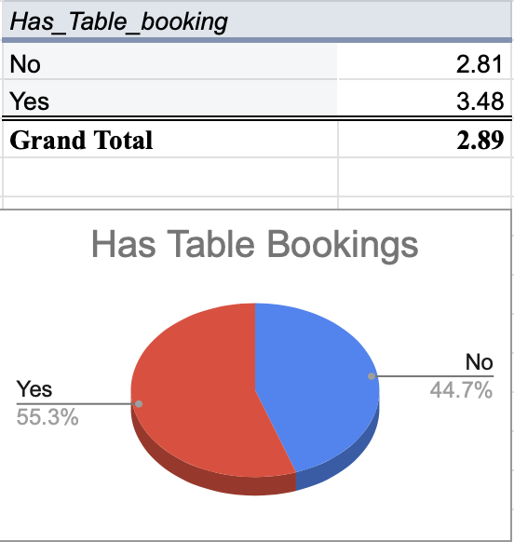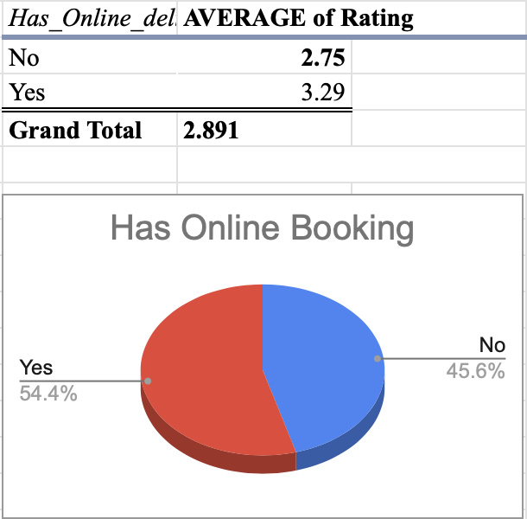
Description:
Pivot tables are used to compare the average ratings of online delivery and booking services, evaluating their impact based on facility availability

Insights:
- Countries that provide online booking and delivery services tend to see an increase in both ratings and votes
- Based on all this data, it's clear that online services are having a positive impact on the rating

Recommendations:
  - Implementing online delivery and table booking services in these countries could provide a competitive advantage.
  - Local restaurants in these countries lack such services

Question 8: Should the team keep the rate of cuisines higher? Will that affect the feedback? According to our data are the rates of cuisines and ratings, correlated?

Solution:
Approach:
We used Excel's =CORREL() function and Pivot Tables to mathematically compare the average cost of dining against the customer ratings for every restaurant in the dataset

=CORREL('Cleaned Data'!S:S,'Cleaned Data'!AA:AA) - Correlation while comparing Ratings and the average price for two in INR - 0.3050549272

=CORREL('Cleaned Data'!S:S,'Cleaned Data'!P:P) - Correlation while comparing Ratings and the Price Range - 0.4629392937

Charts & Tables:
- Table / Chart Name:
Pivot Table

Price_range | AVERAGE of Rating
1 | 2.38
2 | 3.07
3 | 3.71
4 | 3.84

Description:
Showing how the average rating changes as the price range increases and the same is followed when average price for two in INR is increased so does the rating

Insights:
There is a clear positive correlation (0.46) between price and Ratings along with Ratings and the average price for two in INR(0.30) ; the cheapest dining tier averages a low 2.38 rating, while the most expensive premium tier averages a much stronger 3.84 rating

Recommendations:
- Restaurants should not increase prices solely to improve customer ratings.
- If higher prices are introduced, they should be accompanied by improvements in food quality, service, ambience, and overall dining experience to justify the increased cost.

Question 9: What is the distribution of the number of restaurants of different price ranges in all the countries?

Solution:

Approach:
visualized the economic spread of the restaurant market globally

Charts & Tables:
Pivot Table

Country Name (Objective Question 5) | 1 | 2 | 3 | 4
Australia | 4 | 14 | 5 | 1
Brazil | 2 | 7 | 16 | 35
Canada |  | 3 |  | 1
India | 4295 | 2858 | 1111 | 388
Indonesia |  | 1 | 20
New Zealand | 3 | 4 | 17 | 16
Philippines |  | 1 | 12 | 9
Qatar |  | 1 | 5 | 14
Singapore |  | 1 | 5 | 14
South Africa |  | 4 | 17 | 39
Sri Lanka |  | 6 | 11 | 3
Turkey |  | 11 | 18 | 5
United Arab Emirates |  | 9 | 29 | 22
United Kingdom | 4 | 28 | 32 | 16
United States of America | 136 | 165 | 110 | 23

Description:
Showing the total count of budget vs. premium restaurants in each country

Insights:

- India dominates the dataset, with most restaurants in Price Ranges 1 and 2, indicating a strong preference for affordable dining options.
- USA, UAE, and South Africa show a balanced mix of mid-range and premium restaurants (Price Ranges 2 and 3), while Australia, UK, Singapore, and Canada have a greater concentration of premium-priced restaurants (Price Ranges 3 and 4).
- Qatar, Turkey, and Indonesia have relatively few restaurants in the dataset, primarily in higher price ranges, suggesting these are niche or emerging markets with potential for future expansion.

Recomendations:
India & Brazil:
Focus on value-conscious customers by introducing budget meal bundles, cashback offers, loyalty rewards, and easy-to-use price filters. Promote affordable dining options through targeted marketing campaigns to increase engagement.
USA, UAE, UK & Australia:
Strengthen the premium dining segment by featuring high end restaurants, highlighting signature dishes and verified quality badges, and offering exclusive benefits such as priority reservations, curated dining experiences, and member-only discounts.
Emerging Markets (Indonesia, Qatar & Sri Lanka):
Expand gradually by collaborating with local restaurant partners, running city specific promotional campaigns, and testing pricing strategies through pilot programs before scaling operations nationwide.

Question 10: Explain your approach in brief for suggesting countries/cities in order to open new restaurants, if the objective and subjective questions would have not been given to assist you. [you have to give bullet pointers in order to answer this question]

Solution:

Approach:
To determine the most suitable countries and cities for opening new restaurants, a systematic approach was adopted based on key performance indicators and market characteristics:
- Selection of Countries.
- Evaluated countries by examining factors such as the average restaurant rating (specifically considering those with a rating greater than 4).
- Identified countries where the total number of restaurants is currently low, indicating potential market gaps and opportunities for new entrants.
- Considered average vote counts, focusing on countries where restaurants receive a high volume of votes, which suggests active customer engagement and potential demand.

Description:
Data Cleaning: Used TRIM and removed duplicates to ensure no skewed averages.

Geographic Analysis: Used Pivot Tables to find countries with Rating > 4.0 but Restaurant Count < 100.

Engagement Check: Prioritized cities with high Average Votes to ensure an active customer base.

Feature Correlation: Verified if the business model (Delivery/Booking) aligned with what locals rate highly.

Expenditure Review: Compared Average_Cost_for_two to ensure financial feasibility.

